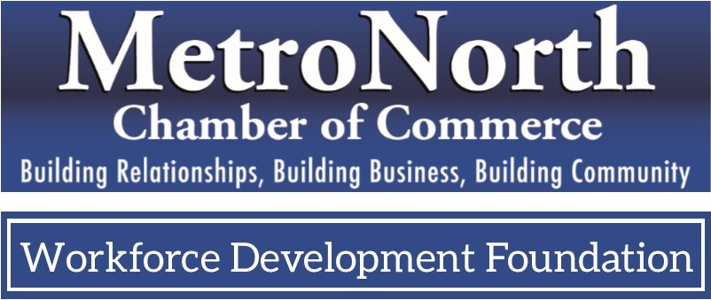
Mission: To invest in quality opportunities today, for a stronger workforce tomorrow.
General Membership Application
I am applying for membership as follows:
I am a member in good standing of the MetroNorth Chamber of Commerce, and therefore automatically eligible to become a member of the Workforce Development Foundation.
Name (please print): _______________________________________Title:________________________
Company Name: _______________________________________________________________________
Address: ___________________________________________________________________________
Phone: ___________________ Cell: ____________________ Email: ____________________________
The Foundation is as strong as the donations it receives. Please check one of the following options:
I will support the Foundation with a financial investment.
_____Suggested amount: 10% of my annual chamber dues.
_____Other:
Make checks payable to the MetroNorth Workforce Development Foundation.

I consider my automatic eligibility for membership my initial investment.
Signature: _________________________________________________________
I understand that my membership includes an annual investment opportunity, and I may be contacted on that basis. I also understand I have the right to attend the Fall Annual Meeting of this Corporation, shall be properly notified of the time and place of that Fall Annual Meeting, and be notified of other Foundation-supported events.

Return completed form to: MetroNorth Chamber Workforce Development Foundation
9380 Central Ave. NE, Suite 320, Blaine, MN 55434 | 763.783.3553 | fax 763.783.3557

